**LESSON PLAN INTEGRATION**

**Team members: Professor:**

Cueto, Neil Orven R. Mr. Ernesto Boydon

Abalon, Jonathan D. **Project Adviser:**

Dagatan, Aaron C. Mr. Jayvee Cabardo

Lavarro, Carl Joshua N.

1. **Introduction**

**1.1 Project Context**

Ville St. John Academy is a Catholic school owned and managed by the Sisters of St. John the Baptist. The school has the utmost conducive atmosphere free from the hassle of the city. It fosters the “Family Spirit” which is clearly seen in the various activities set forth in and outside the school campus. Ville St. John Academy is known in Paranaque for the good facilities and good quality of their education. The school was accredited by Philippine Accrediting Association of Schools, Colleges and Universities (PAASCU) and is also a member of Catholic Educational Association of the Philippines (CEAP).

Part of the school’s system is that teachers should create a lesson plan/daily journal and submit it to their supervisor. Another is that they should submit a list of student grades to the supervisor for them to check. It is a challenge for the teachers to provide a lesson plan that can be helpful for them and be motivating for the students.

Today, the internet is acting a huge role in the developments being made. Many teachers are comfortable on using technologies and internet for that it can provide different sources of knowledge that they could use. There is a need of new development for the teachers in preparing a lesson plan where mobile and internet technology can be applied to help boost the teacher’s productivity and to extend its boundaries in creating or providing a lesson plan outline.

**1.2 Purpose**

The purpose of this study is to identify the problems that teachers experience in submitting or creating their requirements like Lesson Plan and Grades. The study intends to provide a solution which will solve the problem that can also help them take advantage the use of internet and mobile technology on their way of teaching.

**Description**

Since K-12 was already implemented that change most of school’s academic system and teaching techniques, the study focus upon providing the elements to the users that would improve themselves in formulating a reliable and relevant resources that can be sharable with others.

**1.3 Objectives**

The objective of this study is to obtain ways that would make teachers of Ville St. John Academy enhance their capabilities in providing a reliable learning resources in creating a lesson plan for a particular subject.

The study aims to create a system that will improve and increase the effectiveness of the school’s system specifically on the teacher’s academic strategies in proving learning materials that will benefit not only the students but the teachers as well.

The study aims to lessen the problems encountered by the teachers in preparing the lesson plan for the students and at the same time organize and manage their time efficiently in creating lesson plans and that will boost their skills and experiences utilizing internet resources that would help them in coping with the fast growth of technology.

**1.4 Scope and Limitations**

The study would cover the academic system where teachers interact with different administrations and finding an answer to the problems that occur on the system.

It also covers on finding a way to develop and improve their ways in formulating a new context of lesson plan which is cover by the new K-12 system.

The solutions for the system that the team will develop would be using mobile and internet technologies that would allow the users in working with it in a convenient and easy way.

**II. Related Literature/System**

There are several systems that could be used as a references on this project. The following explain each system’s functions and its objectives.

1. The OnCourse Lesson Planner is a 100% web-based program that will streamline and modernize the planning process at your school district. Teachers use intuitive tools to build plans and align them to standards, supportive resources, and homework assignments. Plans can be posted to administrators with a single click, or shared with colleagues using collaborative tools. Teachers can create a multimedia classroom website, where students and parents can access homework, resources, and information that posts automatically from the teacher’s Lesson Planner. Administrators can use the Lesson Planner Reviewer at a desk or on a mobile device for evaluating lesson plans and sending narrative feedback.

OnCourse’s unique, educator-friendly interfaces ensure that teachers, administrators, students, and guardians have easy access to the tools and information they need to be efficient and effective.

Teachers have 24/7 access to the web-based Lesson Planner, which brings convenience to the classroom or home office. Every teacher will always have the most updated version of state/national standards at their fingertips, and can see how many times they’ve taught each standard over the course of the year. They may also participate in faculty-only forums where collaboration, file sharing, and resource creation takes place continuously.

2. PlanbookEDU is an online tool that the teachers can use to keep track of classes, lessons, and standards. This would be helpful specifically for high school teachers who may teach multiple sections of the same class or who may have a schedule that varies from day to day. For instance, a teacher who teaches a section of ninth-grade English could create a "lesson" and add it to their plan book weekly, daily, or whenever they teach the class.

PlanbookEDU also has a collaboration feature with other PlanbookEDU users so that more than one teacher can collaborate on a plan book. This could be helpful for teachers who teach a similar class schedule, or for grade partners in the elementary grades.

3. Learnboost is a great resource for teachers who wish to construct and organize lesson plans. Through an easy to use, step-by-step lesson builder, teachers can easily customize and organize their lesson plans, upload media files, attach common core standards, and track student progress. Teachers can easily customize their plans on the fly and create assessments that align with certain goals. The great thing about LearnBoost is that it provides educators with the freedom to work from anywhere where there is an Internet connection.

Having these related systems will help our project to improve its objectives more only that we included some unique ideas like having our designed system a Search Engine Optimization or SEO as a backend of it. The search engine will help the teachers to look for related learning resources which is stored inside the system’s database based on the topic information they listed in the information form. It will also provide a feature where it automatically compiles the gathered resources and generate it as one.

**1.6 Lesson Plan Integration System Model**

CONTEXT DIAGRAM

LESSON PLAN

LESSON INFORMATION

CREATE LESSON PLAN

TEACHER

SUPERVISOR

FEEDBACK

FEEDBACK

**Appendix**

Diagram 0

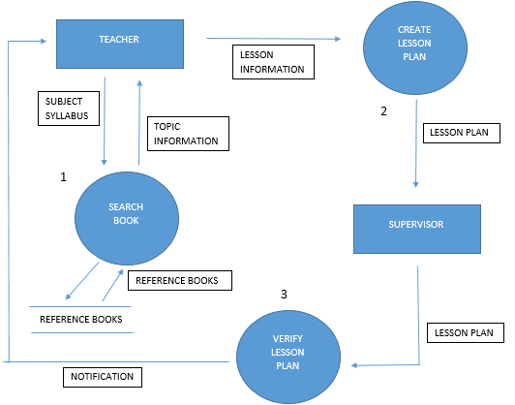

FEEDBACK

**Process Specifications**

**Diagram 1**

* **Review the topic syllabus**
* **Search for related topics in books**
* **Gather topic information**

**Diagram 2**

* **Compile the gathered topic information**
* **Think of class activities**
* **Create a lesson plan**
* **Submit to supervisor / principal**

**Diagram 3**

* **Get the lesson plan**
* **Read the lesson plan**
* **Verify the lesson plan**
* **Send feedback to teachers**

**Entity Relationship Diagram**

**SEARCH**

**REVIEW**

**SUBMIT**

**CREATE**

**SUPERVISOR**

**BOOK**

**LESSON PLAN**

**TEACHER**